Product Code: **BFBVHPP1-D, BFBVHPP1-E, BFBVHPP1-F, BFBVHPP1-G**

Product Description: **High Pressure Part 1 Ball Valve**

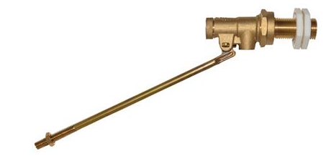

Product Specification:

Material: Brass

Size: ½”, ¾”, 1” and 1 ¼”

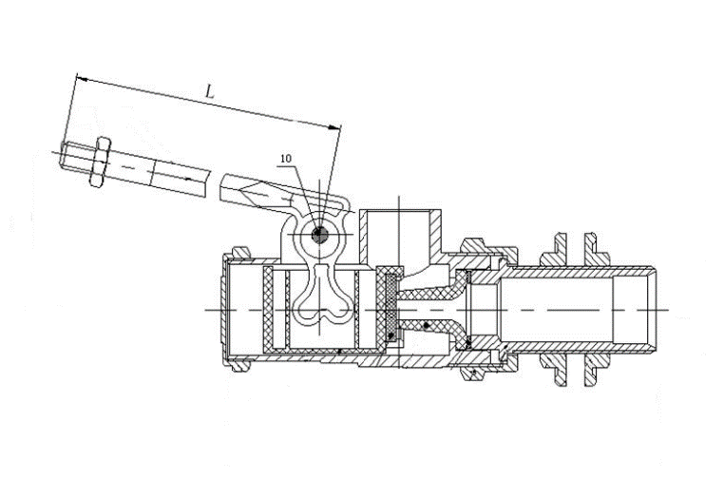

|  |  |  |
| --- | --- | --- |
| Ref | Size | Kgs |
| BFBVHPP1-D | ½” | 0.263 |
| BFBVHPP1-E | ¾” | 0.666 |
| BFBVHPP1-F | 1” | 1.484 |
| BFBVHPP1-G | 1 ¼” | 1.87 |

|  |  |
| --- | --- |
| **Technical Data** |  |
| Field of Application | Suitable for Domestic Cold Water Systems |
| Max. Working Pressure | 0 to 10 Bar |
| Max. Working Temperature | -10°C to 85°C |
|  |  |
|  |  |
| Other Standards/Approvals |  |