Product Code: **BFBVHPP2-D, BFBVHPP2-E**

Product Description: **High Pressure Part 2 Ball Valve**

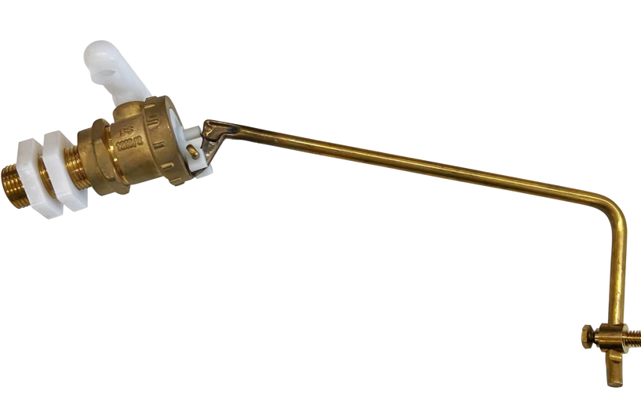

Product Specification:

Material: Brass

Size: ½” and ¾”

|  |  |  |
| --- | --- | --- |
| Ref | Size | Kgs |
| BFBVHPP2-D | ½” | 0.313 |
| BFBVHPP2-E | ¾” | 0.463 |

|  |  |
| --- | --- |
| **Technical Data** |  |
| Field of Application | Suitable for Domestic Cold Water Systems |
| Max. Working Pressure | 0 to 10 Bar |
| Max. Working Temperature | -10°C to 85°C |
|  |  |
|  |  |
| Other Standards/Approvals |  |